Design Portfolio  LinkedIn Resume  UX Lead Portfolio  Design Ethics  AI Architecture  Accessibility Analyst  Case Studies Available  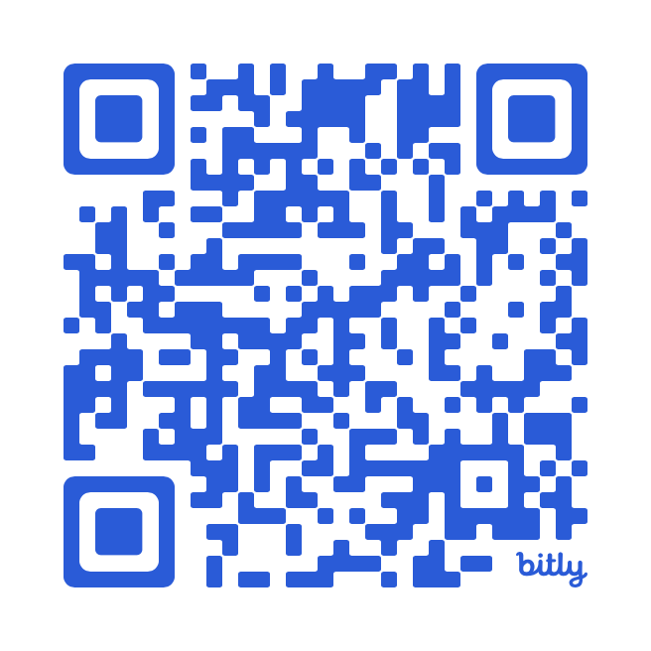  UX/AI Roles  Freelance Design Manager  UX Project Manager  UI/UX Designer  UX Research  Service Designer  UX Architect  Accessibility Analyst  Tools & Methods  LookBack (Usability testing), Adobe Creative Suite, MS Office Suite, Axure, Sketch, Figma, Adobe XD, Miro, LucidChart, Slack, InVision, Lean UX, Design Thinking, and IDEO Workshops  UX Research  Usability Testing, Heuristic Evaluations, Field Studies, Personas, Lean 360 Matrix,  Service Design Blueprints, Customer Journey Maps, UX Workshops, Innovation, and ADA Compliance: WCAG 2.0 and Fed 508 Guidelines |   Candidate Summary  Over the last 15 years, Dave has demonstrated upward mobility, transitioning from a UX Designer to a UX Design Director with an AI Architecture Analyst focus. During this time, Dave has led a wide variety of freelance design, research and UX design projects for world-class companies. His design philosophy: “Whether managing projects or leading workshop sessions, I ensure that your products are useful, usable, and desirable, aligned with measurable business goals. When an effective, holistic methodology is guiding your projects, your organization can be confident that your business objectives, AI strategy, product objectives, and customer experience goals will be met. If you want to securely position your company in the vanguard of progressive methodology, humane technology, and reliable ROI, you've come to the right place.”  Highlights  - 2024 — ETHICO TECHNO: Freelance Design and Media Production  - 2023 — UNIVERSITY OF MINNESOTA, B.A. in Cinema and Media Culture  - 2023 — EGALITARIO: Nonprofit Founder – Brand Steward and Content Strategy  - 2020 — TRANE TECHNOLOGIES: UX Architect & Product Designer  - 2018 — TAYLOR CORPORATION: Product and Service Designer  - 2017 — VERIZON WIRELESS: Accessibility Analyst, UX Research & Writing  - 2016 — BEST BUY: UX Architect managing the Best Buy Pattern Library  - 2013 — MERCK: UX Lead and Strategist for global solutions projects  - 2011 — 3M: Taxonomy and UX Lead for the 3M global redesign  Innovation  - Innovation Workshops  - Lean 360 Matrix – Combining Customer Journey Mapping & Service Design  - Accessibility Pattern Library proposal - Verizon Wireless  - Egalitario – Nonprofit organization  Industry Sectors  Retail, Healthcare, Financial, Energy, Academic, Telecom and AI

Employment History

UX Lead: EthicoTechno, Minneapolis, MN - Remote 5/2020 – Present
Working primarily on freelance design and startup initiatives, our team provides AI strategy, UX Research, Design Management, UX Design, and Usability Engineering. Notable Entrepreneurial Projects: Egalitario – This nonprofit seeks to provide products that support social service and environmental solutions innovation and AI Chatbot Products Analysis. Deliverables: Startup Service Design Blueprints, UX Research and Testing, AI Chatbot Product enhancements, Business Analysis, and Design Systems Integration.

UX Lead: Trane Technologies, St. Paul, MN – FT 1/2019 – 5/2020
This role included UX Research, UX Product Design, and UX Strategy, supporting Trane's sustainable, energy management solutions. Notable Projects: Gridflex – an energy management product and Digital Maintenance Solutions (DMS) a product for remote RTU monitoring and maintenance systems. Deliverables: Usability Testing, Personas, Surveys, Global Project Summary Reports, Field Studies, Customer Journey Maps, User Stories, UI Prototyping - Figma, and UX Strategy Consulting Reports

UX Lead: Taylor Digital, Minneapolis, MN – Hybrid 4/2018 – 11/2018
This UX Research Management, UX Architecture and Design role was focused on improving a product used by the company to facilitate customer orders. The initial Discovery work included Stakeholder Interviews, User Interviews, Field Studies, Personas, Requirements gathering, and Conceptual Prototypes. Notable Projects: Product Software redesign of the customer call center. Deliverables: Customer Journey Mapping, Personas, Assumption Requirements, Wireframes, and a Google Material Design System Plan and Schematics.

Volunteering: UX Project Manager: A LIST APART 10/2017 –1/2020
Managed internal projects for this web design resources company: SEO Audit, Articles Organization, Accessibility, etc.
Notable Projects: n/a. Deliverables: Consulting Input and Communication

Accessibility Analyst: Verizon, NJ – Hybrid 1/2017 – 6/2017
Our initiatives support Verizon’s compliance, testing and research to provide the best accessibility features and functions for people with disabilities. Other projects included working with Opinion Lab data to learn more about our customers’ experience.
Notable Projects: Benchmarking Report on Telecom Accessibility and a Community Outreach Initiative for expanding Accessibility Educational Opportunities for disenfranchised youth. Deliverables: A11y Analysis, Telecom Benchmarking reports, and Community Development proposals.

UX Lead: Best Buy, Minneapolis, MN – Contract 4/2016 – 9/2016
UX Research, Project Management, Implementation Strategy, Content Writing, and UX Lead supporting the design and development of the Best Buy Corporate Pattern Library. Notable Projects: Designing and managing the expansion of the Best Buy Pattern Library; Validating the Key Business Requirements (KBRs) & Key Performance Indicators (KPIs), Copywriting, UX Architecture, and Hybrid Business Analysis. Deliverables: Weekly Reports, New Patterns, Project Timeline Review, UX Insights and Recommendations.

UX Lead: Merck, Rahway, NJ – Contract 6/2011 – 3/2013
Throughout my engagement at Merck, I worked primarily on global initiatives for improving Merck’s internal products and services.
Notable Projects: Global Careers website redesign; SharePoint Knowledge Base - UX Architecture & IA; Global Help Desk support consolidation collaborating with Big Data using UX Transaction and Help Ticket Analysis; Intranet Customer Journey Mapping, and Site Search Analytics; Merck HR end-to-end process study; Usability Testing of Merck Labs pharmaceutical software. Deliverables: UX Research Reports, UX Design Solutions, Customer Journey Maps, UX Evangelizing Presentations and UX Design.

UX Director: Gage Marketing, Minneapolis, MN – FT 2/2010 –6/2011
After a UX Team decided to leave the company, I successfully planned, implemented, grew, and managed a new UX team at Gage, expanding into four FT employees and three Contractors. We worked on typical UX projects, including User Research, Accessibility Governance, Usability Testing, Surveys, Personas, UX Architecture, RFPs, Web Analytics Consulting with 3M SMEs, and Taxonomy analysis. Notable Projects: Collaborated with other UX Teams to redesign 3M.com’s global; Design Collaboration on 3M, and UHG mobile initiatives – iOS, Android; UX Research supporting Microsoft internal sales portal redesign and usability testing. Deliverables: RFPs, UX Research Reports, UX Designs, UX Evangelizing Presentations, and Strategic UX Solutions for world-class companies.

UX Lead: Wells Fargo, Anoka, MN – Contract 1/2009 – 8/2009
User Experience Research and Design, Information Architecture, Pattern Library, and Business Analysis integration. Notable Projects: Crop Insurance (CIMax) product and Proposal for the RCIS Pattern Library initiative. Deliverables: Discovery Research, UX Architecture, User Interviews, Pattern Library proposals, Software UI Design, Wireframes, UX Reports, Workshops, Project Estimating, and Agile Cycles.

Education

University of Minnesota, B.A.
Cinema and Media Culture (SCMC)
Research focus: Media Literacy, Human Factors & Ergonomics (HFE), Social Media Platforms, Product Analysis Case Studies, Smartphone Addiction, Tech Innovation, and Blockchain Exchange for Social Good.

Community

Contributions
Montreal City Mission, The Prem Rawat Foundation, Red Cross, Out Front - Minnesota, Amnesty International, United Nations (Darfur), Riverside People's Clinic, Common Ground Meditation Center, Doctors Without Borders, Colorado Organization for Victim Assistance, and the New York Coalition for the Homeless.

Pro Bono/Volunteer Work
(Global, remote) The Prem Rawat Foundation - Writer and CMS Support - 2018
(Global, remote) A List Apart - Project Manager - 2017- 2018
(Local, on site) Middle School Science Fair judging, as a representative of Trane Technologies. - 2020

